**SKIN DISEASE DETECTION USING MACHINE LEARNING**

**A PROJECT REPORT**

***Submitted by***

**ADHITHYAN K - 810019205005**

**AGASTAN A - 810019205006**

***in partial fulfilment for the award of the degree of***

**BACHELOR OF TECHNOLOGY**

***in***

**INFORMATION TECHNOLOGY**



**DEPARTMENT OF INFORMATION TECHNOLOGY**

**UNIVERSITY COLLEGE OF ENGINEERING, BIT CAMPUS, TIRUCHIRAPPALLI – 620 024**

**ANNA UNIVERSITY : CHENNAI 600 025**

**MAY 2023**

**ANNA UNIVERSITY : CHENNAI 600 025**

**BONAFIDE CERTIFICATE**

Certified that this project report **“SKIN DISEASE DETECTION AND RECOMMENDATION SYSTEM USING MACHINE LEARNING ”** is the bonafide work of “**ADHITHYAN K (810019205005)** and **AGASTAN A (810019205006) ”** who carried out the project work under my supervision, for the partial fulfilment of the requirements for the award of the degree of Bachelor of Technology. Certified further that to the best of my knowledge and belief, the work reported here in does not form part of any other thesis or discussion on the basis of which a degree or an award was conferred on an earlier occasion

**SIGNATURE SIGNATURE**

**Dr. G. ANNAPOORANI**  **Mr. T. JAISON VIMALRAJ**

**HEAD OF THE DEPARTMENT SUPERVISOR**

Assistant Professor Teaching Fellow

Department of CSE Department of IT

University College of Engineering University College of Engineering

BIT - Campus BIT - Campus

Tiruchirappalli - 620024 Tiruchirappalli - 620024

Submitted for “IT8811 – Project Work” in B.TECH Information Technology Degree April-May 2023 Examination held on ………………..

**INTERNAL EXAMINER** **EXTERNAL EXAMINER**

**DECLARATION**

We hereby declare that the work entitled **“SKIN DISEASE DETECTION USING MACHINE LEARNING”** is submitted in partial fulfilment of the requirement for the award of the degree in Bachelor of Technology in Information Technology in University College of Engineering, BIT-Campus, Anna University, Tiruchirappalli. It is a record of our own work carried out by us during the academic year 2022 – 2023 under the supervision and guidance of **Mr.T. JAISON VIMALRAJ**, Teaching Fellow, Department of Information Technology. The extent and source of information are derived from the existing literature and have been indicated through the dissertation at the appropriate places. The matter embodied in this work is original and has not been submitted for the award of any other degree, either in this or any other University.

**SIGNATURE OF CANDIDATES**

ADHITHYAN K (810019205005)

AGASTAN A (810019205006)

I certify that the declaration made above by the candidates is true.

**SIGNATURE OF THE GUIDE**

**Mr. T . JAISON VIMALRAJ**

Teaching Fellow

Department of IT

University College of Engineering BIT – Campus

Tiruchirappalli – 620 024

**ACKNOWLEDGEMENT**

A truthful heartfelt and deserved acknowledgement comes from one’s heart to convey the real influence others have on one’s work.

We would like to thank our honourable Dean **Dr. T. SENTHILKUMAR, M.E., Ph.D.,** for giving us a chance to complete education in one of the reputed government institutions running under his leadership.

We express our sincere gratitude to our head of the department **Dr. G. ANNAPOORANI, M.Tech., Ph.D.,** for giving us the provision to do the project.

We are much obliged to our project coordinators **Dr. K. UMA MAHESWARI, M.Tech., Ph.D.,** and **Mr. K. SARAVANA KUMAR, M.Tech.,** andour class coordinator **Dr. K. UMA MAHESWARI, M.Tech., Ph.D.,** for giving us an opportunity to do the project, heartly thanks to them.

We stand even more thankful to our project mentor **Mr.T.JAISON VIMALRAJ, M.E.,** for guiding us throughout the project.

We also express our sincere thanks to all other staff members, friends, and our parents for their help and encouragement.

**­ ADHITHYAN K**

**AGASTAN A**

**ABSTRACT**

Skin diseases are prevalent worldwide and can have a significant impact on a person's quality of life. Early and accurate diagnosis of skin conditions is crucial for timely treatment and management. With the advancements in machine learning techniques, there is an increasing interest in developing automated systems for skin disease detection. This paper presents a novel approach for skin disease detection using machine learning algorithms The trained model is then evaluated on a separate test dataset to assess its performance in accurately classifying skin diseases. Various performance metrics, such as accuracy, precision, recall, and F1 score, are calculated to quantify the system's diagnostic capabilities. The results demonstrate the potential of the proposed approach in achieving high accuracy rates and effectively distinguishing between different skin diseases. The application provides real-time predictions and offers additional information about the detected disease, including possible treatment options and recommendations. This technology can significantly assist dermatologists in their diagnostic process, improve access to skin disease detection in underserved areas, and empower individuals to seek timely medical intervention. The proposed system shows promising results and offers a valuable tool for early diagnosis and intervention, ultimately improving patient outcomes in the field of dermatology .***Keywords - Skin disease detection, Machine learning,*** ***Web-based application Healthcare professionals , Skin image analysis , Treatment recommendation***

**TABLE OF CONTENTS**

**CHAPTER NO. TITLE PAGE NO.**

**ABSTRACT v**

**LIST OF FIGURES viii**

**LIST OF ABBREVIATIONS ix**

1. **INTRODUCTION**  **1**

1.1 BACKGROUND AND SIGNIFICANCE 1

1.2 IMPORTANCE OF ACCURATE DIAGNOSIS 1

1.3 ROLE OF MACHINE LEARNING 2

1.3.1 DATA COLLECTION 3

**2.** **LITERATURE REVIEW 4**

**3.** **SYSTEM ANALYSIS 9**

3.1 EXISTING SYSTEM 9

3.1.1 DISADVANTAGE 9

3.2 PROPOSED SYSTEM 11

3.2.1 OBJECTIVES 11

3.2.2 FUNCTIONALITIES 11

3.2.3 ADVANTAGES 12

3.2.4 ALGORITHM 14

**4.** **SYSTEM DESIGN 15**

4.1 SYSTEM ARCHITECTURE 15

4.2 ARCHITECTURE EXPLANATION 16

**5.**  **SYSTEMATIC DIAGRAMS 17** 5.1 ENTITY RELATIONSHIP DIAGRAM 17

5.2 DATA FLOW DIAGRAM 18

5.3 USE CASE DIAGRAM 19

**6. SYSTEM REQUIREMENTS 20**

6.1 EXTERNAL INTERFACE 20

6.1.1 USER INTERFACE 20

6.1.2 HARDWARE INTERFACE 20

6.1.3 SOFTWARE INTERFACE 20

6.2 SOFTWARE DESCRIPTIONS 21

6.2.1 FRONTEND 21

6.2.2 BACKEND 21

**7. SYSTEM IMPLEMENTATION 22**

7.1 MODULES DESCRIPTION 22

7.1.1 DATA ACQUISITION 22

7.1.2 DATA PREPROCESSING 22

7.1.3 FEATURE EXTRACTION 22

7.1.4 MODEL TRAINING 22

7.1.5 PREDICTION AND DETECTION 22

7.3 CODE 23

7.4 OUTPUT SCREENSHOTS 44

**8. CONCLUSION AND FUTURE WORK 48**

8.1 CONCLUSION 48

8.2 FUTURE ENHANCEMENT 48

**REFERENCES 49**

**LIST OF FIGURES**

**FIGURE NO. NAME PAGE NO.**

3.2.4 Working of SVM Algorithm 14

4.1 System Architecture Diagram 15

5.1 Entity Relationship Diagram 17

5.2.1 DFD Level 0 18

5.2.2 DFD Level 1 18

5.3 Use Case Diagram 19

7.4.1 Home Page of Skin Disease Detection 44

7.4.2 About Skin Disease 44

7.4.3 Upload Image 45

7.4.4 ML Prediction 45

7.4.5 Dataset Images 46

7.4.6 Prediction Output 46

7.4.7 Our Team 47

7.4.8 Contact Info 47

**LIST OF ABBREVIATIONS**

ML - Machine Learning

CNN - Convolutional Neural Network

SD - Skin Disease

SVM - Support Vector Machine

DFD - Data Flow Diagram

GUI - Graphical User Interface

ER - Entity Relationship Diagram

**CHAPTER 1**

**INTRODUCTION**

**1.1 Background and significance of skin disease detection**

Skin disease detection plays a vital role in healthcare due to the high prevalence and impact of skin conditions on individuals. Skin diseases affect a substantial portion of the global population, ranging from common issues like acne to more severe conditions such as psoriasis or skin cancer. These ailments can cause physical discomfort, pain, disfigurement, and significant psychological distress, impacting a person's overall well-being and quality of life. Accurate and timely detection of skin diseases is crucial for effective management and treatment. Visual examination alone may not always be sufficient, as many skin conditions present with similar symptoms, making differential diagnosis challenging. Furthermore, delayed or incorrect diagnoses can lead to inappropriate treatments, disease progression, and increased healthcare costs. Therefore, the development of reliable and efficient methods for skin disease detection is essential to ensure early intervention, appropriate care, and improved outcomes for patients.

**1.2 Importance of accurate diagnosis**

Early and accurate diagnosis of skin diseases holds immense significance in healthcare. Timely identification of skin conditions allows for prompt initiation of treatment, preventing the progression of the disease and minimizing its impact on the individual's health. By detecting skin diseases at an early stage, healthcare professionals can implement appropriate interventions that alleviate symptoms, reduce the severity and duration of the condition, and improve treatment outcomes. Furthermore, early diagnosis enables personalized management strategies tailored to the specific skin disease, optimizing therapeutic interventions and minimizing the risk of complications. Beyond physical health, early diagnosis also addresses the psychological and emotional well-being of patients, reducing anxiety, distress, and the potential negative effects on self-esteem. Additionally, early detection contributes to public health by curbing the spread of contagious skin diseases and optimizing resource allocation within the healthcare system. Overall, early and accurate diagnosis of skin diseases is crucial for timely treatment, improved patient outcomes, effective disease management, and the well-being of individuals.

**1.3. ROLE OF MACHINE LEARNING**

Machine learning has emerged as a powerful tool in dermatology, revolutionizing the field and significantly impacting disease detection, diagnosis, and treatment. With its ability to analyze large datasets and recognize complex patterns, machine learning algorithms have shown great potential in enhancing the accuracy and efficiency of dermatological practices. In the realm of skin disease detection, these algorithms can analyze diverse sets of patient data, including clinical images, electronic health records, and pathology reports, to aid in the early and accurate diagnosis of various skin conditions. Machine learning algorithms can learn from vast amounts of labeled data, enabling them to distinguish subtle differences between different skin diseases and assist healthcare professionals in making more precise diagnoses. Additionally, machine learning models can contribute to the development of predictive models for skin diseases, helping to identify high-risk individuals and enabling preventive measures. Moreover, in treatment planning, machine learning algorithms can suggest personalized therapeutic options based on patient-specific characteristics and previous treatment outcomes, facilitating more effective and tailored approaches. The integration of machine learning in dermatology has the potential to improve patient care, optimize resource allocation, and advance our understanding of skin diseases by leveraging the power of data-driven insights and intelligent algorithms.

**1.3.1 Data Collection**

Data collection and preprocessing are crucial steps in the utilization of machine learning algorithms for dermatology. Collecting high-quality and diverse datasets is essential to train robust models that can generalize well to real-world scenarios. Dermatology datasets typically consist of clinical images, patient records, and demographic information. The collection process involves collaborating with healthcare institutions, dermatology clinics, and research studies to gather representative samples covering a wide range of skin conditions. Ensuring data privacy and ethical considerations are paramount during data collection to protect patient confidentiality. Once collected, the data undergoes preprocessing steps to clean and prepare it for analysis. This involves removing noise, outliers, and redundant information, standardizing formats, and addressing missing values. Image data may require additional preprocessing techniques like resizing, cropping, and normalization. Preprocessing plays a critical role in enhancing the quality and consistency of the dataset, reducing bias, and improving the performance of machine learning algorithms for accurate diagnosis and treatment recommendations in dermatology.

**CHAPTER 2**

**LITERATURE REVIEW**

**Skin Disease detection based on different Segmentation Techniques:**

[1] Kyamelia Roy, Sheli Sinha Chaudhuri, Sanjana Ghosh, Swarna Kamal Dutta, Proggya Chakraborty, Rudradeep Sarkar states that The outer integument of the human body is skin. The skin pigmentation of human beings varies from person to person and human skin type can be dry, oily, or combination. Such a variety in the human skin provides a diversified habitat for bacteria and other microorganisms. Melanocytes in the human skin, produces melanin which can absorb harmful ultraviolet radiation from sunlight which can damage the skin and result in skin cancer. The necessary tools needed for early detection of these diseases are still not a reality in most third world communities. If the symptoms of skin diseases such as acne, dermatomyositis, candidiasis, cellulitis, Scleroderma, chicken pox, ringworm, eczema, psoriasis, etc. are left untreated in its early stage then they can result in numerous health complications and even death. Image segmentation is a technique which aids with the detection of these skin diseases. In this paper, image processing techniques like adaptive thresholding, edge detection, K-means clustering and morphology-based image segmentation have been used to identify the skin diseases from the given image set. The acquired image set was pre-processed by deblurring, noise reduction and then processed. Depending on the definite pattern (pertaining to a distinct disease) present in the processed image the disease is detected at the output for a corresponding input image.

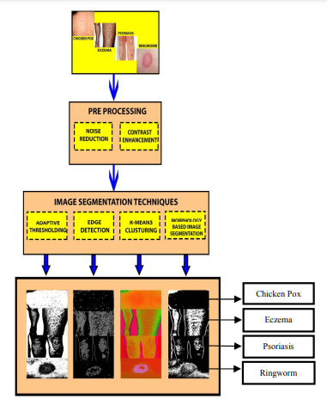

**Skin Lesion Classification Using Convolutional Neural Network With Novel Regularize:**

[2] Marwan ali albahar states a One of the most common types of human malignancies is skin cancer, which is chiefly diagnosed visually, initiating with a clinical screening followed by dermoscopic analysis, histopathological assessment, and a biopsy. Due to the fine-grained differences in the appearance of skin lesions, automated classification is quite challenging through images. To attain highly segregated and potentially general tasks against the finely grained object categorized, deep convolutional neural networks (CNNs) are used. In this paper, we propose a new prediction model that classifies skin lesions into benign or malignant lesions based on a novel regularizer technique. Hence, this is a binary classifier that discriminates between benign or malignant lesions. The proposed model achieved an average accuracy of 97.49%, which in turns showed its superiority over other state-of-the-art methods. The performance of CNN in terms of AUC-ROC with an embedded novel regularizer is tested on multiple use cases. The area under the curve (AUC) achieved for nevus against melanoma lesion, seborrheic keratosis versus basal cell carcinoma lesion, seborrheic keratosis versus melanoma lesion, solar lentigo versus melanoma lesion is 0.77, 0.93, 0.85, and 0.86, respectively. Our results showed that the proposed learning model outperformed the existing algorithm and can be used to assist medical practitioners in classifying various skin lesions.

**Skin Disease Classification System Based on Machine Learning Technique:**

[3] Saja Salim mohammed and Jamal Mustafa Al-Tuwaijari said that Skin diseases are a major and worrying problem in societies due to their physical and psychological effects on patients. Detecting skin diseases at an early stage has an important role in treatment. The process of diagnosing and treating skin injury is related to the skill and experience of the specialist doctor. The diagnostic process must be accurate and timely. Recently, artificial intelligence science has been used in the field of diagnosing skin diseases through the use of machine learning algorithms and the exploitation of the vast amount of data available in health centers and hospitals. In this paper, quite many previous studies related to methods of classification of skin diseases based on the principle of machine learning were collected. In a group of previous studies, the researchers used some systems, mechanisms, and algorithms. Several systems have been successful in classifying skin diseases and achieving varying diagnostic accuracy. Various systems have relied on methods of image processing and feature extraction that help predict and detect disease type. There are other systems designed to identify specific types of skin disease through clinical features and features obtained from tissue analyzes after a skin biopsy of the affected area. This survey shows that the diagnostic accuracy in image processing methods was relatively uneven, ranged between (50% to 100%). As for the methods of treating tissue features, the accuracy was of an excellent level of 94% or more. The results provide an overview of the actual relevant studies found in the literature and highlight most of which research gaps have emerged.

**Skin Disease Image Recognition:**

[4] Ling-fang li , Xu wang, Wei-jian hu, Neal n. Xiong , (senior member, ieee), Yong-xing du, and Bao-shan li prposed that The application of deep learning methods to diagnose diseases has become a new research topic in the medical field. In the field of medicine, skin disease is one of the most common diseases, and its visual representation is more prominent compared with the other types of diseases. Accordingly, the use of deep learning methods for skin disease image recognition is of great significance and has attracted the attention of researchers. In this study, we review 45 research efforts on the identification of skin disease by using deep learning technology since 2016.

We analyze these studies from the aspects of disease type, data set, data processing technology, data augmentation technology, model for skin disease image recognition, deep learning framework, evaluation indicators, and model performance. Moreover, we summarize the traditional and machine learning-based skin disease diagnosis and treatment methods. We also analyze the current progress in this field and predict four directions that may become the research topic in the future. Our results show that the skin disease image recognition method based on deep learning is better than those of dermatologists and other computer-aided treatment methods in skin disease diagnosis, especially the multi deep learning model fusion method has the best recognition effect.

**A Method Of Skin Disease Detection Using Image Processing And Machine Learning:**

[5]Nawal Soliman ALKolifi ALEnezi proposed that Skin diseases are more

in the detection of skin diseases in a variety of techniques. Due to deserts and hot weather, skin diseases are common in Saudi Arabia. This work contributes in the research of skin disease detection. We proposed an image processing-based method to detect skin diseases. This method takes the digital image of disease effect skin area, then use image analysis to identify the type of disease. Our proposed approach is simple, fast and does not require expensive equipment other than a camera and a computer.

The approach works on the inputs of a color image. Then resize the of the image to extract features using pretrained convolutional neural network. After that classified feature using Multiclass SVM. Finally, the results are shown to the user, including the type of disease, spread, and severity. The system successfully detects 3 different types of skin diseases with an accuracy rate of 100%.

**CHAPTER 3**

**SYSTEM ANALYSIS**

**3.1 EXISTING SYSTEM**

There are several existing models that have been successfully applied to skin disease detection using machine learning. One such model is Inception-v3, a deep convolutional neural network (CNN) architecture. Inception-v3 has shown promising results in accurately classifying skin lesions by extracting hierarchical features from images. Its architecture includes multiple layers with parallel convolutional operations, allowing it to capture both local and global information from the input image. Another popular model is DenseNet, which is also a CNN architecture specifically designed for image classification tasks. DenseNet introduces skip connections between layers, enabling better information flow and gradient propagation. This architecture has demonstrated excellent performance in capturing fine-grained features and improving the accuracy of skin disease classification. Additionally, ResNet, a deep residual CNN architecture, has been widely utilized in skin disease detection. ResNet addresses the vanishing gradient problem by introducing skip connections that allow gradients to flow more easily. This enables the model to effectively capture and learn complex patterns in skin images. These models, among others, have shown their effectiveness and potential in advancing the field of skin disease detection using machine learning.

**3.1.1 DISADVANTAGES**

1. Computational Complexity: These deep learning models, including Inception-v3, DenseNet, and ResNet, are computationally intensive and require significant computational resources for training and inference. Training these models on large datasets can be time-consuming and may require powerful hardware, such as GPUs or TPUs, to achieve reasonable training times.

2. Data Requirements: Deep learning models like Inception-v3, DenseNet, and ResNet often require a large amount of labeled data for training. Collecting and annotating diverse and well-balanced datasets with accurate labels can be challenging and time-consuming, particularly in the field of dermatology where expert dermatologist annotations are required.

3. Interpretability: Deep learning models are known for their black-box nature, making it challenging to interpret the decision-making process of these models. It may be difficult to understand the specific features or factors that contribute to the model's predictions. This lack of interpretability can be a limitation in the medical field where explanations for diagnoses are highly valuable.

4. Sensitivity to Noise and Variations: These models may be sensitive to image quality, noise, and variations in lighting, orientation, or image acquisition settings. Performance can degrade when tested on images from different sources or with different levels of noise or artifacts, impacting their robustness and generalizability.

5. Deployment Constraints: Deploying deep learning models like Inception-v3, DenseNet, and ResNet in resource-constrained environments, such as mobile devices or edge devices, can be challenging due to their computational and memory requirements. Model optimization and efficient deployment strategies may be necessary to make them practical for real-time applications.

6. Overfitting: Deep learning models, including Inception-v3, DenseNet, and ResNet, can be prone to overfitting, especially when trained on relatively small or imbalanced datasets. Overfitting occurs when the model learns to memorize the training data rather than capturing generalizable patterns. Mitigating overfitting often requires regularization techniques, data augmentation, or larger datasets.

**3.2 PROPOSED SYSTEM**

**3.2.1 OBJECTIVES**

The primary objectives of the proposed system are as follows:

* Develop a machine learning model capable of accurately classifying various skin diseases.
* Create an intuitive user interface for capturing skin images and presenting diagnostic results.
* Enhance the efficiency and effectiveness of skin disease diagnosis, reducing the need for invasive and costly procedures.
* Improve accessibility to skin disease diagnosis by providing a convenient and user-friendly platform.

**3.2.2 FUNCTIONALITIES**

Skin disease detection using machine learning functionalities, specifically utilizing the Support Vector Machine (SVM) algorithm, has shown promising results in the field of dermatology. SVM is a supervised learning algorithm commonly employed for classification tasks.In the context of skin disease detection, the SVM algorithm works by mapping input image features to a higher-dimensional space, where it attempts to find an optimal hyperplane that separates different skin disease classes.. To implement the SVM algorithm for skin disease detection, a comprehensive dataset comprising labeled skin lesion images is required. Relevant features, such as color, texture, shape, and spatial information, are extracted from the images. These features serve as input to the SVM model. The SVM algorithm then learns from the labeled data by iteratively adjusting its parameters to identify the best hyperplane that accurately separates different skin disease classes. The algorithm aims to achieve high accuracy in classifying new, unseen skin lesion images based on the learned patterns from the training data.

Evaluation and validation of the SVM model are crucial to assess its performance. This involves testing the model on independent datasets and comparing its predictions against expert dermatologists' diagnoses. Various metrics, such as accuracy, precision, recall, and F1-score, are used to evaluate the model's performance and determine its effectiveness in detecting and classifying different skin diseases. Skin disease detection using SVM offers several advantages, including its ability to handle non-linear data and its robustness against noise.. Regular updates and refinements to the model are necessary to accommodate new skin disease patterns and improve its accuracy over time. The SVM algorithm can serve as a valuable tool to support dermatologists in the early detection and classification of skin diseases, ultimately improving patient outcomes and facilitating timely treatment.

**3.2.3 ADVANTAGES**

* **Effective in High:** SVMs perform well in scenarios where the number of features is large, such as in skin disease detection where various image characteristics are considered. SVMs can handle high-dimensional data effectively and are known for their ability to generalize well in such settings.
* **Robustness to Noise:** SVMs are known to be robust against noisy data. Skin lesion images may contain variations due to factors like lighting conditions, image quality, and patient characteristics. SVMs can handle these variations and still produce accurate results by finding the optimal hyperplane that separates classes effectively.
* **Flexibility with Kernel Functions:** SVMs offer flexibility in dealing with non-linearly separable data through the use of kernel functions. By applying different kernel functions, such as linear, polynomial, RBF, or sigmoid kernels, SVMs can capture complex relationships in the data and improve classification performance.
* **Strong Generalization:** SVMs are designed to find the hyperplane that maximizes the margin, or distance, between data points of different classes. This focus on maximizing the margin leads to models that generalize well to unseen data. SVMs have demonstrated excellent generalization capabilities, making them suitable for skin disease detection tasks.
* **Feature Selection:** SVMs can help identify the most informative features for classification. Through the optimization process, SVMs prioritize relevant features that contribute to the separation of different skin disease classes. This feature selection property can aid in identifying key image characteristics associated with specific skin diseases.
* **Handling Small Sample Sizes**: SVMs can effectively handle small sample sizes, making them useful in situations where data availability is limited. In dermatology, obtaining labeled skin lesion images can be challenging, especially for rare or specific skin conditions. SVMs can still learn meaningful patterns from a small dataset and make accurate predictions.
* **Interpretable Results:** SVMs provide interpretable results by generating decision boundaries and support vectors. These boundaries can offer insights into the characteristics that distinguish different skin diseases. Such interpretability can aid dermatologists in understanding the underlying factors contributing to the algorithm's predictions.
* **Well-Established Algorithm:** SVMs have been extensively studied and widely used in various domains, including medical applications. Their effectiveness and reliability have been demonstrated in numerous studies, establishing SVMs as a trusted and robust machine learning algorithm.

**3.2.4 ALGORITHM**

Support Vector Machine (SVM) is a machine learning algorithm commonly used for skin disease detection. It works by classifying data, such as images, into different categories based on their features. To use SVM for skin disease detection, you need to collect a dataset of skin disease images and preprocess them by extracting relevant features like color, texture, or shape. Split the dataset into training and testing sets, and then train the SVM model on the training data. The model learns to separate different classes by finding an optimal decision boundary. Evaluate the model's performance using the testing dataset, and fine-tune it if needed. Once trained, the SVM model can be used to predict skin diseases on new, unseen data. However, it's crucial to ensure a representative dataset, choose appropriate features, and optimize the model to achieve accurate skin disease detection.

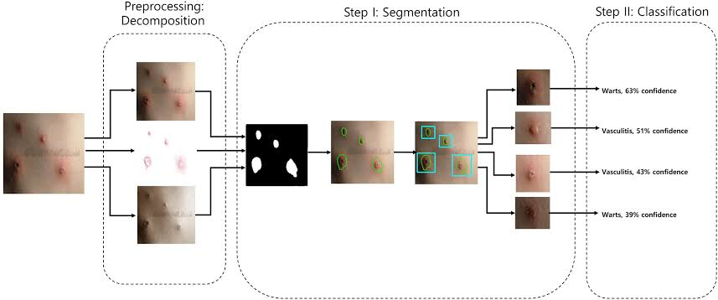

*Fig 3.2.4 Working of SVM Algorithm*

**CHAPTER 4**

**SYSTEM DESIGN**

**4.1 SYSTEM ARCHITECTURE**

The system architecture for skin disease detection using machine learning typically involves several key components and stages. The first step is data acquisition, where a dataset of skin disease images or relevant data is collected, encompassing a diverse range of skin conditions. Once the dataset is obtained, it undergoes preprocessing to prepare it for analysis The trained model is then evaluated using the testing set to assess its performance and generalization ability. Once the model is trained and validated, it can be utilized for predicting the presence of skin diseases on new, unseen data, enabling automated and accurate skin disease detection.

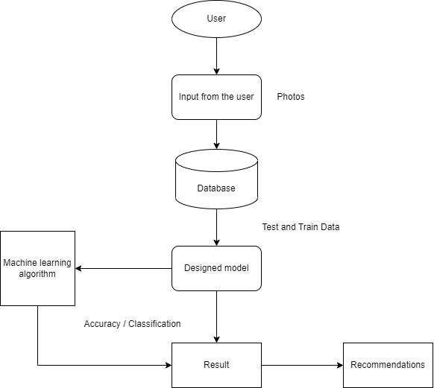

*Fig 4.1 System Architecture Diagram*

**4.2 ARCHITECTURE EXPLANATION**

The process begins with data acquisition, where a dataset comprising images or relevant data related to skin diseases is collected. This dataset should include samples representing a wide range of skin conditions to ensure the model's ability to detect and classify different diseases effectively.Once the dataset is obtained, it undergoes preprocessing to prepare the data for analysis. Preprocessing steps include tasks such as image resizing, normalization, and noise reduction to standardize the data and improve its quality.The preprocessed data is then fed into the feature extraction stage. In this stage, relevant features are extracted from the skin disease images. These features capture important characteristics such as color, texture, or shape that are indicative of various skin diseases. The training set is used to train a machine learning model, such as SVM depending on the specific requirements. The model learns to identify patterns and relationships between the extracted features and the corresponding disease labels during the training process.Following model training, the performance of the trained model is evaluated using the testing set..Once the model is trained, validated, and deemed satisfactory, it can be deployed for real-time prediction and detection of skin diseases. New, unseen skin disease images can be input into the trained model, which will classify and identify the disease based on the learned patterns and features. This enables automated and accurate detection of skin diseases, aiding in early diagnosis and appropriate treatment.Overall, the architecture for skin disease detection using machine learning encompasses data acquisition, preprocessing, feature extraction, model training and evaluation, and real-time prediction. This comprehensive approach leverages the power of machine learning algorithms to analyze skin disease images and make accurate diagnoses, thereby assisting healthcare professionals and improving patient outcomes.

**CHAPTER 5**

**SYSTEMATIC DIAGRAMS**

**5.1 ENTITY RELATIONSHIP DIAGRAM**

ER model stands for an Entity-Relationship model. It is a high-level data model. This model is used to define the data elements and relationship for a specified system. It develops a conceptual design for the database. It also develops a very simple and easy to design view of data. In ER modeling, the database structure is portrayed as a diagram called an entity-relationship diagram

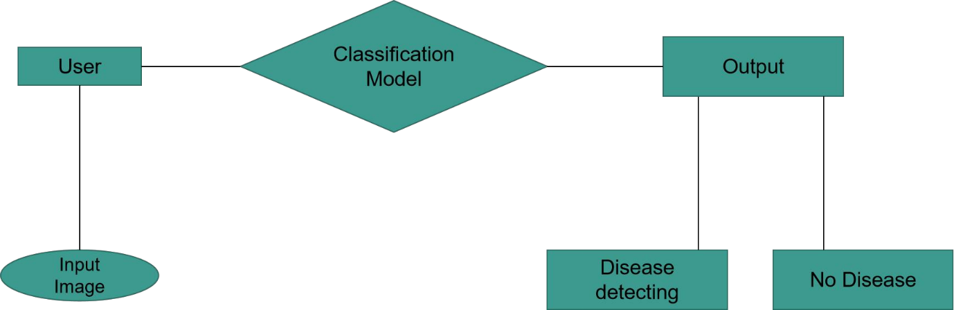

*Fig 5.1 Entity Relationship Diagram*

**5.2 DATA FLOW DIAGRAM**

A Data Flow Diagram (DFD) is a traditional visual representation of the information flows within a system. A neat and clear DFD can depict the right amount of the system requirement graphically. It can be manual, automated, or a combination of both. It shows how data enters and leaves the system, what changes the information, and where data is stored.

The objective of a DFD is to show the scope and boundaries of a system as a whole. It may be used as a communication tool between a system analyst and any person who plays a part in the order that acts as a starting point for redesigning a system. The DFD is also called as a data flow graph or bubble chart.

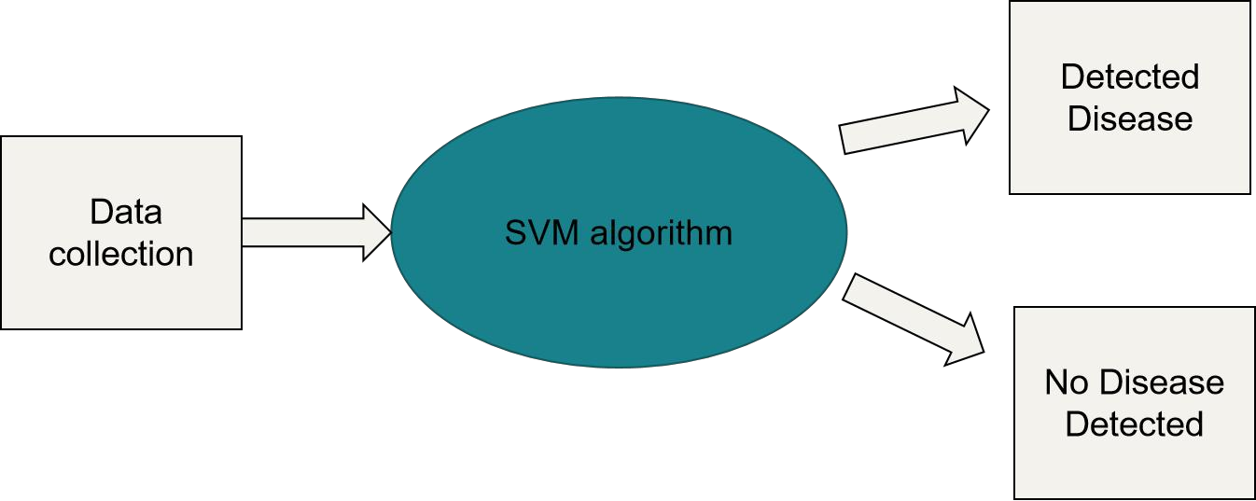

*Fig 5.2.1 DFD Level 0*

First Level DFD (1st Level) of Campus Recruitment System shows how the system is divided into sub-systems (processes), each of which deals with one or more of the data flows to or from an external agent, and which together provide all of the functionality of the E-commerce and Crop Prediction System as a whole.

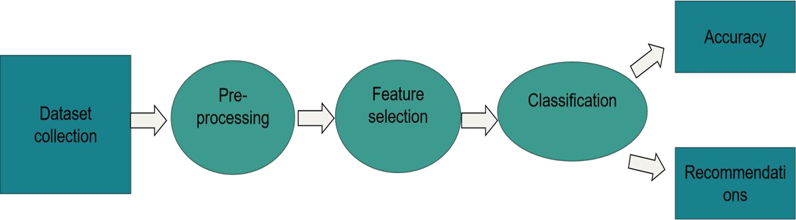

*Fig 5.2.2 DFD Level 1*

**5.3 USE CASE DIAGRAM**

The use case diagram for skin disease detection using machine learning illustrates the interactions between the system and its users, representing the different functionalities and actors involved. The "Upload Image" use case involves users uploading skin disease images to the system for analysis. Once uploaded, the system performs preprocessing steps,through the "Preprocess Image" use case. The extracted features are utilized to "Train the Model" using a labeled dataset, enabling the model to learn patterns and relationships. The "Test Model" use case evaluates the model's performance by applying it to a separate dataset. Once trained and validated, the system can "Make Predictions" on new, unseen skin disease images, providing classification and identification. The results are displayed through the "Display Results" use case, offering information about the detected skin disease, including the predicted label and confidence score.

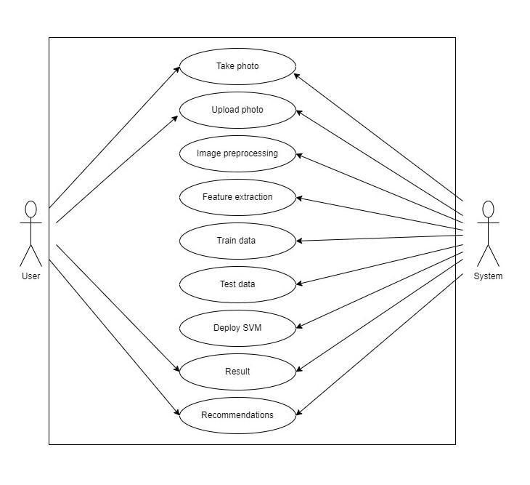*Fig 5.3 Use Case Diagram*

**CHAPTER 6**

**SYSTEM REQUIREMENTS**

**6.1 EXTERNAL INTERFACE**

The different types of interfaces that we would come across while developing the SKIN DISEASE DETECTION application are as follows:

* User Interface
* Hardware Interface
* Software Interface

**6.1.1 USER INTERFACE**

The GUI of the product shall be designed in HTML ,CSS,JS allowing a multitude of different user’s access. It helps us to design an elegant system which is supported by every browser.

* Front-end Software: HTML, CSS , JS
* Back-end Software: PYTHON

**6.1.2 HARDWARE INTERFACE**

An internet connection to allow the browser software interfaces to connect to the internet access for the files of the website and the api.

* Windows
* A browser which supports new version javascript

**6.1.3 SOFTWARE INTERFACE**

The languages, codes and messages that program use to communicate with each other and to the hardware

* Operating System: Windows 11
* Database: Python Flask
* Code Editor: Visual Studio Code and Jupyter Notebook

**6.2 SOFTWARE DESCRIPTION**

**6.2.1 FRONT END – HTML , CSS**

The front end of the skin disease detection software is built using HTML, CSS, and JavaScript to create an interactive and user-friendly interface. It provides an intuitive platform for users to input images of skin conditions and receive accurate predictions about the potential diseases.

**6.2.2 BACKEND – PYTHON (FLASK)**

The back end of the skin disease detection software is built using Python, which serves as the primary programming language for implementing the machine learning model and handling the data processing tasks. Python offers a wide range of libraries and frameworks that are essential for training the model, making predictions, and providing the necessary functionality for the software.

Once the model is trained, Python enables the deployment of the model in the back end. Frameworks like Flask is commonly used to develop web APIs that expose the machine learning functionality to the front end. These frameworks handle the routing of requests from the front end, allowing the user to submit an image and receive the predicted results.

**CHAPTER 7**

**SYSTEM IMPLEMENTATION**

**7.1 MODULE DESCRIPTION**

**7.1.1 MODULE 1**: Data Acquisition:

This module focuses on acquiring a diverse and representative dataset of skin disease images. It involves sourcing data from various reliable sources, such as medical databases, research repositories, or collaborations with healthcare institutions.

**7.1.2 MODULE 2:** Data Preprocessing:

The data preprocessing module is responsible for cleaning and preparing the acquired dataset for analysis. It involves tasks such as image resizing, normalization, noise reduction, and data augmentation techniques to ensure standardized and high-quality data.

**7.1.3 MODULE 3:** Feature Extraction:

In this module, relevant features are extracted from the preprocessed images. Various feature extraction techniques can be utilized, such as or Support Vector Machine . The goal is to capture discriminative characteristics that can differentiate between different skin diseases.

**7.1.4 MODULE:** Model Training:

The model training module focuses on training a machine learning model using the extracted features and labeled data. Different algorithms like Support Vector Machines The model learns to recognize patterns and relationships between the features and disease labels

**7.1.5 MODULE :** Prediction and Detection:

The prediction and detection module allows users to input new, unseen skin disease images to the trained model. The model applies the learned patterns and features to predict the presence of skin diseases and classify them accordingly.

**7.3 CODE**

*Skin disease detection .ipynb*

import os

import numpy as np

import cv2

from sklearn import svm

from sklearn.metrics import accuracy_score

train_path = 'C:/Users/agastan/Downloads/archive/train/'

test_path = 'C:/Users/agastan/Downloads/archive/test/'

categories = ['Actinic Keratosis Basal Cell Carcinoma and other Malignant Lesions', 'Atopic Dermatitis Photos', 'Acne and Rosacea Photos']

image_size = (64, 64)

def preprocess_image(image):

image = cv2.resize(image, image_size)

image = cv2.cvtColor(image, cv2.COLOR_BGR2GRAY)

image = image.flatten()

return image

train_images = []

train_labels = []

test_images = []

test_labels = []

for category in categories:

train_category_path = os.path.join(train_path, category)

for filename in os.listdir(train_category_path):

image_path = os.path.join(train_category_path, filename)

image = cv2.imread(image_path)

image = preprocess_image(image)

train_images.append(image)

train_labels.append(categories.index(category)

test_category_path = os.path.join(test_path, category)

for filename in os.listdir(test_category_path):

image_path = os.path.join(test_category_path, filename)

image = cv2.imread(image_path)

image = preprocess_image(image)

test_images.append(image) test_labels.append(categories.index(category))

train_images = np.array(train_images)

train_labels = np.array(train_labels)

test_images = np.array(test_images)

test_labels = np.array(test_labels)

svm_classifier = svm.SVC(kernel='linear')

svm_classifier.fit(train_images, train_labels)

y_pred = svm_classifier.predict(test_images)

accuracy = accuracy_score(test_labels, y_pred)

print('Accuracy:', accuracy)

test_image1 = 'C:/Users/agastan/Downloads/archive/test/Atopic Dermatitis Photos/4th1IMG015.jpg'

from keras_preprocessing import image

test_image1 = image.load_img(test_image1)

test_image1 = image.img_to_array(test_image1)

test_image1 = preprocess_image(test_image1)

test_image1 = np.expand_dims(test_image1,axis=0)

pred = svm_classifier.predict(test_image1)

print(categories[pred[0]])

pickle.dump(svm_classifier,open('D:/Final_Project/skindiseasemodel.pkl','wb')

load_model = pickle.load(open('D:/Final_Project/skindiseasemodel.pkl','rb'))

pred = load_model.predict(test_image1)

print(categories[pred[0]])

app.py:

from flask import Flask, render_template, request, flash, redirect

import os

import cv2

from keras_preprocessing import image

import pickle

import numpy as np

app = Flask(_name_)

ALLOWED_EXTENTSIONS = set(['png','jpg','jpeg','gif'])

def allowed_file(filename):

return '.' in filename and filename.rsplit('.',1)[1].lower() in ALLOWED_EXTENTSIONS

image_size = (64, 64)

categories = ['Actinic Keratosis Basal Cell Carcinoma and other Malignant Lesions', 'Atopic Dermatitis Photos', 'Acne and Rosacea Photos']

def preprocess_image(image):

image = cv2.resize(image, image_size)

image = cv2.cvtColor(image, cv2.COLOR_BGR2GRAY)

image = image.flatten()

return image

@app.route("/")

def home():

return render_template('index.html', name = "Choose file to get result")

@app.route('/result', methods=['POST'])

def upload_file():

if request.method == 'POST':

if 'file' not in request.files:

flash('No file part')

return redirect(request.url)

file = request.files['file']

if file.filename == '':

flash('No file selected for uploading')

return redirect(request.url)

if file:

file.save(file.filename)

filename = os.path.abspath(file.filename)

test_image1 = image.load_img(filename)

test_image1 = image.img_to_array(test_image1)

test_image1 = preprocess_image(test_image1)

test_image1 = np.expand_dims(test_image1,axis=0)

load_model = pickle.load(open('D:/Final_Project/skindiseasemodel.pkl','rb'))

pred = load_model.predict(test_image1)

print(categories[pred[0]])

result = categories[pred[0]]

return render_template("result.html", name = result)

return render_template("index.html", name = "No file found")

# for debugging

if _name_ == "_main_":

app.run(debug=True)

index.html

<!DOCTYPE html>

<html lang="en">

<head>

<meta charset="UTF-8">

<meta http-equiv="X-UA-Compatible" content="IE=edge">

<meta name="viewport" content="width=device-width, initial-scale=1.0">

<title>Document</title>

<link rel="stylesheet" href="/static/style.css">

<link href="https://cdn.jsdelivr.net/npm/bootstrap@5.0.2/dist/css/bootstrap.min.css" rel="stylesheet">

<link rel="stylesheet" href="https://cdnjs.cloudflare.com/ajax/libs/font-awesome/5.15.3/css/all.min.css">

</head>

<body>

<header class="fixed-top py-3">

<div class="container d-flex align-items-center justify-content-between">

<a href="#" class="logo">Skin Care<span class="fas fa-bacteria"></span></a>

<div id="menu-bar" class="fas fa-bars d-inline-block d-md-none"></div>

<nav class="nav">

<a href="#home">home</a>

<a href="#about">about</a>

<a href="#check">check my skin type</a>

<a href="#contact">contact</a>

</nav>

</div>

</header>

<section class="home" id="home">

<div class="container">

<div class="row min-vh-100 align-items-center pt-5">

<div class="col-md-6">

<img src="../static//images/istockphoto-1248674930-612x612-removebg-preview.png" class="w-100" alt="">

</div>

<div class="col-md-6 content text-center text-md-start pl-md-5">

<span>your skin is your best accessory </span>

<h3>protect yourself from skin disease</h3>

<a href="#" class="link-btn">learn more</a>

</div>

</div>

</div>

</section>

<section class="about" id="about">

<div class="container">

<div class="row align-items-center flex-wrap-reverse">

<div class="col-md-6 content">

<h3>What are Skin Diseases?</h3>

<p>Skin diseases are conditions that affect your skin. These diseases may cause rashes, inflammation, itchiness or other skin changes. Some skin conditions may be genetic, while lifestyle factors may cause others. Skin disease treatment may include medications, creams or ointments, or lifestyle changes.</p>

<a href="#" class="link-btn">learn more</a>

</div>

<div class="col-md-6">

<img src="../static/images/conifer-1127-removebg-preview.png" class="w-100" alt="">

</div>

</div>

</div>

</section>

{% block content %}

<section class="check" id="check">

<form action="/result" method="post" enctype="multipart/form-data">

<h1 class="heading"><span>Check Your Skin Type</span></h1>

<center>

<input type="file" id="custom-button" autocomplete="off" name="file"/>

<button type="submit" id="submit-button">Submit</button>

</center>

</form>

<center>{{name}}</center>

</section>

{% endblock %}

<section class="contact" id="contact">

<h1 class="heading"> <span>contact</span> Us </h1>

<div class="container">

<div class="row flex-wrap-reverse">

<div>

<form action="">

<input type="text" placeholder="name" class="box">

<input type="email" placeholder="email" class="box">

<input type="number" placeholder="number" class="box">

<textarea name="" placeholder="message" id="" cols="30" rows="10"></textarea>

<input type="submit" class="link-btn" value="send message" name="" id="">

</form>

</div>

</div>

</div>

</section>

<section class="footer">

<div class="container">

<div class="d-flex flex-wrap justify-content-center text-center text-sm-start">

<div class="box p-3 m-2">

<h3>quick links</h3>

<a href="#home">home</a>

<a href="#about">about</a>

<a href="#check">check my skin type</a>

<a href="#contact">contact</a>

</div>

<div class="box p-3 m-2">

<h3>Connect with us</h3>

<a href="#">facebook</a>

<a href="#">instagram</a>

<a href="#">linkedin</a>

<a href="#">twitter</a>

</div>

<div class="box p-3 m-2">

<h3>contact info</h3>

<a href="#">+91 63795 11975</a>

<a href="#">+91 75581 66938</a>

<a href="#" style="text-transform: lowercase;">aagastan4@gmail.com</a>

<a href="#">Tamilnadu, India - 620 024</a>

</div>

</div>

<div class="credit"> created by <span>AgastanAdhithyan</span> | all rights reserved </div>

</div>

</section>

<script src="main.js"></script>

</body>

</html>

style.css

:root{

--main-color:#926ad4;

--black:#244361;

--box-shadow:0 5px 10px rgba(0,0,0,.1);

}

*{

margin:0; padding:0;

box-sizing: border-box;

outline: none; border:none;

text-decoration: none !important;

text-transform: capitalize;

font-family: Verdana, Geneva, Tahoma, sans-serif;

}

html{

scroll-padding-top: 60px;

}

section{

padding:20px 0;

}

section:nth-child(odd){

background:white;

}

.heading{

text-align: center;

padding:0 15px;

padding-bottom: 5px;

color:var(--black);

font-size: 30px;

}

.heading span{

color:var(--main-color);

}

.link-btn{

display: inline-block;

background:var(--main-color);

color:#fff;

border-radius: 50px;

padding:10px 25px;

font-size: 17px;

cursor: pointer;

box-shadow: var(--box-shadow);

}

.link-btn:hover{

color:#fff;

background:magenta;

}

header{

box-shadow: var(--box-shadow);

background: #fff;

}

header .logo{

font-size: 20px;

color:var(--black);

}

header .logo span{

color:var(--main-color);

}

header .nav a{

margin-left: 3px;

border-radius: 50px;

color:var(--black);

padding:5px 15px;

}

header .nav a:hover{

background: var(--main-color);

box-shadow: var(--box-shadow);

color:#fff;

}

#menu-bar{

color:var(--black);

cursor: pointer;

font-size: 25px;

transition: .2s linear;

}

.home{

min-height: 100vh;

background: url(/Images/home-bg.png) no-repeat;

background-position: center;

background-size: cover;

}

.home .content span{

color:var(--main-color);

font-size: 20px;

}

.home .content h3{

color:var(--black);

font-size: 50px;

font-weight: bolder;

}

.about .content h3{

color:var(--black);

font-size: 33px;

}

.about .content p{

color:#777;

font-size: 14px;

}

.prevent .box{

flex:1 1 300px;

background:#f8f8fe;

border-radius: 5px;

text-align: center;

}

.prevent .box img{

margin-bottom: 10px;

height: 70px;

}

.prevent .box h3{

color:var(--black);

font-size: 20px;

}

.prevent .box p{

color:var(--black);

font-size: 14px;

}

#custom-button {

padding: 10px;

color: white;

background-color: var(--main-color);

border: 1px solid;

border-radius: 5px;

width: 100%;

min-width: 50px;

max-width: 300px;

font-size:0.875em;

display:block;

left:-60px;

margin-top:35px;

cursor: pointer;

}

#custom-button:hover {

background-color: magenta;

}

#custom-text {

margin-left: 10px;

font-family: sans-serif;

color: black;

}

#submit-button {

padding: 10px;

color: white;

background-color: var(--main-color);

border: 1px solid;

border-radius: 5px;

width: 100%;

min-width: 70px;

max-width: 300px;

font-size:1em;

display:block;

left:-60px;

margin-top:35px;

cursor: pointer;

}

#submit-button:hover {

background-color: magenta;

}

.experts .box{

width:260px;

background:#fff;

border-radius: 5px;

box-shadow: var(--box-shadow);

margin:5px;

padding:15px;

text-align: center;

position: relative;

overflow: hidden;

}

.experts .box img{

background:#f8f8fe;

border-radius: 5px;

width: 100%;

margin-bottom: 8px;

}

.experts .box h3{

font-size: 22px;

margin:2px 0;

color:var(--black);

}

.experts .box span{

font-size: 15px;

color:var(--main-color);

}

.experts .box .share{

position: absolute;

top:5px; right: -50px;

transition: .2s;

}

.experts .box:hover .share{

right:15px;

}

.experts .box .share a{

border-radius: 5px;

background:var(--main-color);

color:#fff;

display: block;

height: 40px;

width: 40px;

line-height: 40px;

margin-top: 5px;

}

.experts .box .share a:hover{

background:var(--black);

}

.contact form{

padding:15px;

border-radius: 5px;

box-shadow: var(--box-shadow);

}

.contact form .box,

.contact form textarea{

background:#f8f8fe;

border-radius: 5px;

font-size: 17px;

padding:10px;

margin:7px 0;

width: 100%;

text-transform: none;

color:var(--black);

}

.contact form textarea{

resize: none;

height: 200px;

}

.contact .map{

border-radius: 5px;

height: 100%;

width:100%;

}

.footer .box{

flex:1 1 250px;

}

.footer .box h3{

font-size: 20px;

color:var(--black);

}

.footer .box p{

color:#777;

}

.footer .box a{

display: block;

font-size: 14px;

color:#777;

padding:5px 0;

}

.footer .box a:hover{

color:var(--main-color);

}

.footer .credit{

text-align: center;

color:var(--black);

border-top: 1px solid rgba(0,0,0,.1);

margin-top: 10px;

padding-top: 20px;

}

.footer .credit span{

color:var(--main-color);

}

@media (max-width:991px){

.home .content h3{

font-size: 30px;

}

}

@media (max-width:768px){

header .nav{

position: absolute;

top:100%; left: 0; right: 0;

background: #fff;

border-top: 1px solid rgba(0,0,0,.1);

border-bottom: 1px solid rgba(0,0,0,.1);

transition: .2s linear;

clip-path: polygon(0 0, 100% 0, 100% 0, 0 0);

}

header .nav.active{

clip-path: polygon(0 0, 100% 0, 100% 100%, 0% 100%);

}

header .nav a{

display: block;

width: 100%;

margin:10px;

}

.fa-times{

transform: rotate(180deg);

}

}

main .js :

let menu = document.querySelector('#menu-bar');

let nav = document.querySelector('.nav');

menu.onclick = () =>{

menu.classList.toggle('fa-times');

nav.classList.toggle('active');

}

let section = document.querySelectorAll('section');

let navLinks = document.querySelectorAll('header .nav a');

window.onscroll = () =>{

menu.classList.remove('fa-times');

nav.classList.remove('active');

section.forEach(sec =>{

let top = window.scrollY;

let height = sec.offsetHeight;

let offset = sec.offsetTop - 150;

let id = sec.getAttribute('id');

if(top >= offset && top < offset + height){

navLinks.forEach(links =>{

links.classList.remove('active');

document.querySelector('header .nav a[href*='+id+']').classList.add('active');

});

};

})

}

const realFileBtn = document.getElementById("real-file");

const customBtn = document.getElementById("custom-button");

const customTxt = document.getElementById("custom-text");

customBtn.addEventListener("click", function() {

realFileBtn.click();

});

realFileBtn.addEventListener("change", function() {

if (realFileBtn.value) {

customTxt.innerHTML = realFileBtn.value.match(

/[\/\\]([\w\d\s\.\-\(\)]+)$/

)[1];

} else {

customTxt.innerHTML = "No file chosen, yet.";

}

});

**7.4 OUTPUT SCREENSHOTS**

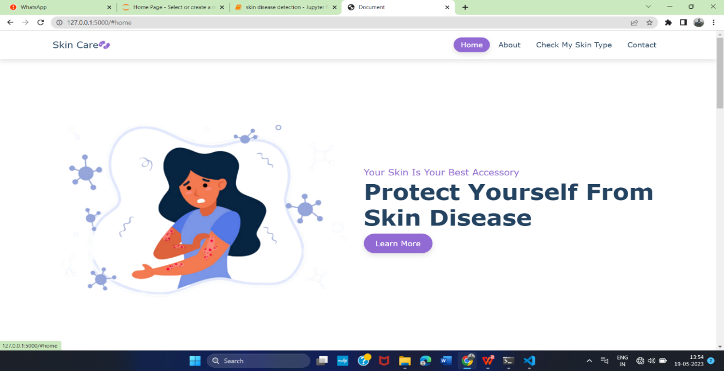

*Fig 7.4.1 Home Page of Skin Disease Detection*

The Home Page contains the details about the skin and skin care and skin disease .

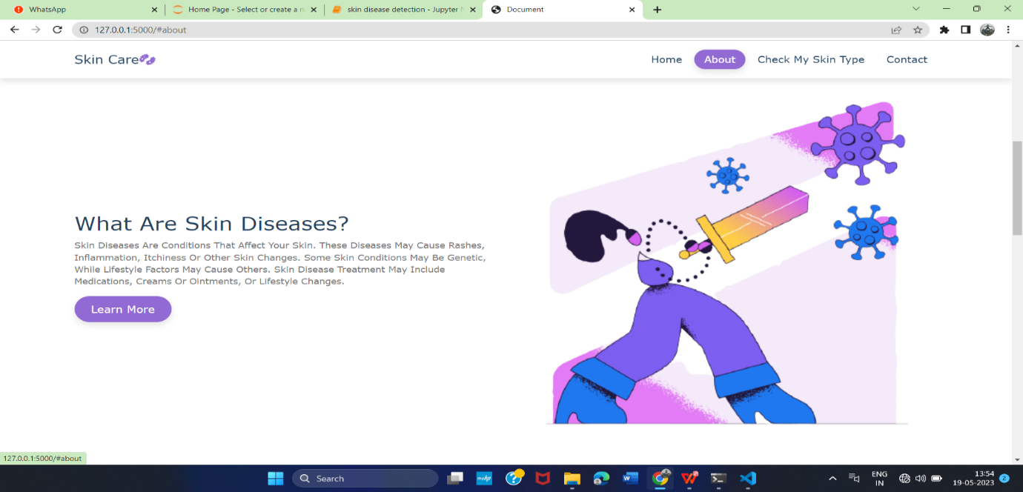

*Fig 7.4.2 About Skin Disease*

This page describe about the skin disease can manifest with various symptoms such as itching, redness, inflammation, scaling, or the formation of lesions

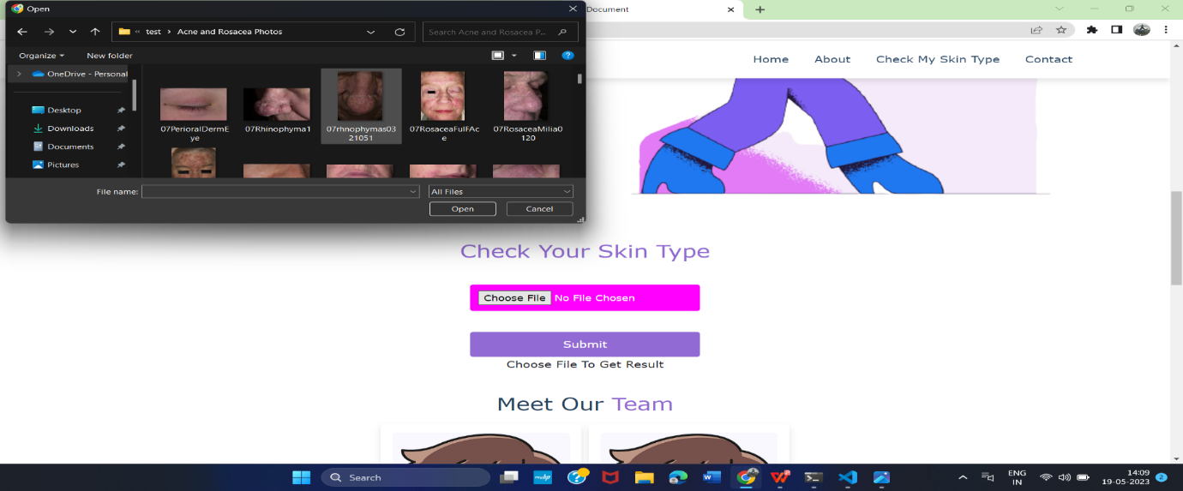

*Fig 7.4.3 Upload Image*

User can upload their image and automated image analysis and machine learning algorithms play a crucial role in analyzing the uploaded images, comparing them to known patterns and disease characteristics, and providing users with an indication of whether the disease is likely present or not.

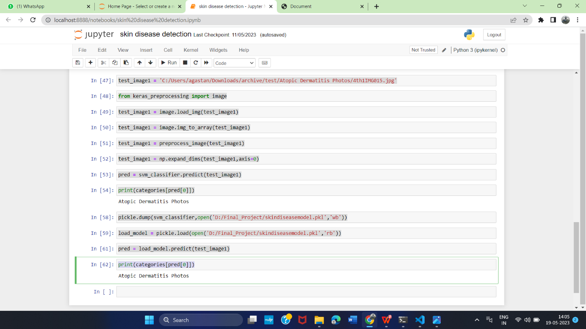

*Fig 7.4.4 ML Prediction*

This page is contains the machine learning code which gives the accuracy and the uploaded image is which type of skin disease and the whole machine learning code is presented here .



*7.4.5 Data set*



*Fig 7.4.5 Prediction output*

This Page shows the final result of the skin disease detection

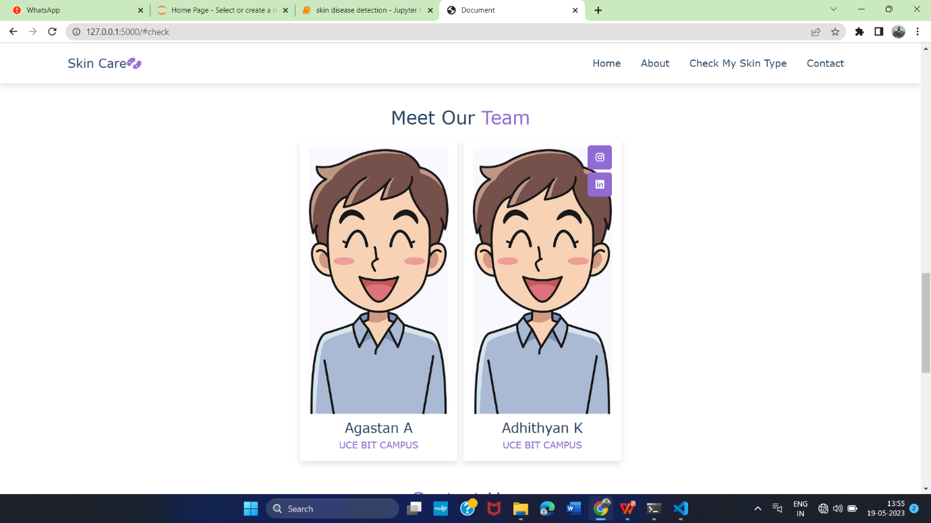

*Fig 7.4.6 Our Team*

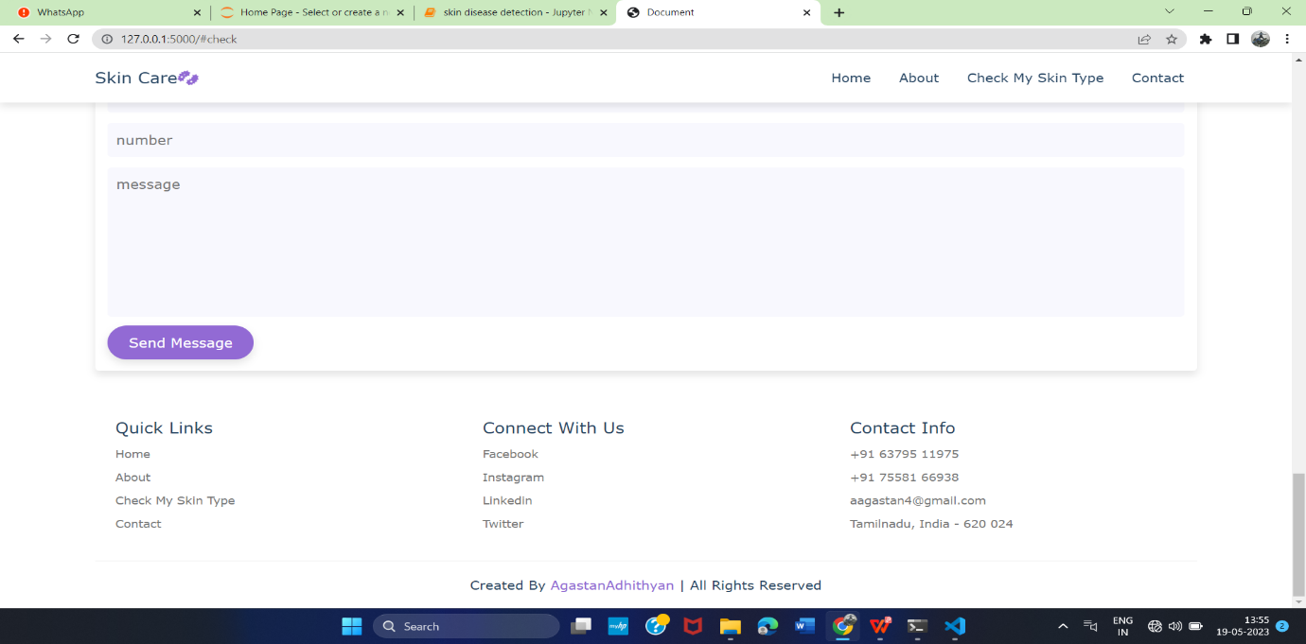

*7.4.7 Contact info*

Thi*s* page contains the team who create this page and also user can interact with us, if user have any issue or any queries about the web page they can contact us through the phone or mail.

**CHAPTER 8**

**CONCLUSION AND FUTURE WORK**

**8.1 CONCLUSION**

In conclusion, skin disease detection using machine learning holds significant promise in revolutionizing the field of dermatology and improving patient care. By harnessing the power of advanced algorithms and image analysis techniques, this approach enables automated and accurate detection of various skin conditions. Moreover, it offers individuals the opportunity to actively engage in their own skin health by providing accessible and user-friendly tools for self-assessment. As machine learning algorithms continue to advance, the future of skin disease detection looks promising, with the potential to revolutionize the field and enhance the quality of care provided to patients.

the integration of machine learning in skin disease detection holds significant

potential for improving the accuracy and efficiency of dermatological diagnoses. It has the capacity to enhance the quality of care provided to patients and assist healthcare professionals in managing skin conditions more effectively. Continued research and development in this field have the potential to revolutionize dermatology and contribute to advancements in personalized medicine

**8.2 FUTURE ENHANCEMENT**

As future work, we are planning to integrate online pharmacy ecommerce website user can also buy a medicine in our web page .

**REFERENCES**

[1] Kyamelia Roy, Sheli Sinha Chaudhuri, Sanjana Ghosh, Swarna Kamal Dutta, Proggya Chakraborty, Rudradeep Sarkar “Skin Disease detection based on different Segmentation Techniques”,2019.

[2] Marwan ali albahar , “Skin Lesion Classification Using Convolutional Neural Network With Novel Regularize”,2019.

[3] Saja Salim mohammed and Jamal Mustafa Al-Tuwaijari, “*Skin Disease Classification System Based on Machine Learning Technique”*,2021 .

[4] Ling-fang li , Xu wang, Wei-jian hu, Neal n. Xiong , (senior member, ieee), Yong-xing du, and Bao-shan li*: Skin Disease Image Recognition:2020.*

[5] Nawal Soliman ALKolifi ALEnezi “*A Method Of Skin Disease Detection Using Image Processing And Machine Learning:2019*,

[6]Arifin, S., Kibria, G., Firoze, A., Amini, A., & Yan, H. (2012) “Dermatological Disease Diagnosis Using Color-Skin Images.” Xian:

International Conference on Machine Learning and Cybernetics.

[7] Yasir, R., Rahman, A., & Ahmed, N. (2014) “Dermatological Disease Detection using Image Processing and Artificial Neural Network.

“Dhaka: International Conference on Electrical and Computer Engineering.

[8] Santy, A., & Joseph, R. (2015) “Segmentation Methods for Computer Aided Melanoma Detection.” Global Conference Communication Technologies.

[9] Zeljkovic, V., Druzgalski, C., Bojic-Minic, S., Tameze, C., & Mayorga, P. (2015) “ Supplemental Melanoma Diagnosis for Darker

Skin Complexion Gradients.” Pan American Health Care Exchanges

[10] Suganya R. (2016) “An Automated Computer Aided Diagnosis of Skin Lesions Detection and Classification for Dermoscopy Images.”

International Conference on Recent Trends in Information Technology.

[11] Alam, N., Munia, T., Tavakolian, K., Vasefi, V., MacKinnon, N., & Fazel-Rezai, R. (2016) “Automatic Detection and Severity

Measurement of Eczema Using Image Processing.” IEEE.

[12] Kumar, V., Kumar, S., & Saboo, V. (2016) “Dermatological Disease Detection Using Image Processing and Machine Learning.” IEEE.

[13] Krizhevsky, A., ILYA, S., & Geoffrey, E. (2012) “ImageNet Classification with Deep Convolutional Neural Networks.” Advances in

Neural Information Processing Systems.

[14] Cristianini, N., Shawe, J., “Support Vector Machines”, 2000.

[15] SOMMERVILLE, I., “Software Engineering”. 9th .2011.